**Tools to build your security around your home**

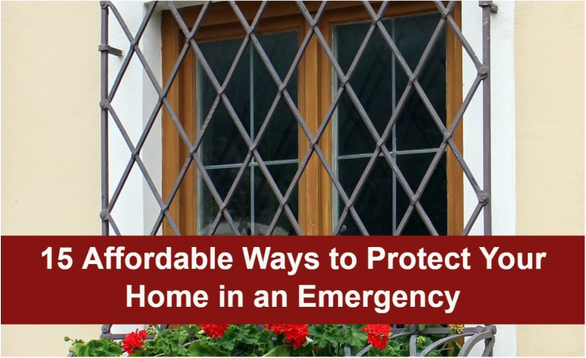

​Those people could become a real threat and may be willing to do you serious harm to take what you have, including your home. You have to be able to protect your home and ultimately, the people sheltering inside. The supplies you have in your home are going to be extremely valuable. Having food, water and first aid supplies will be critical to your survival, which is why it is important you guard and protect what you have. Imagine being tossed out into the street without nothing more than the clothes on your back. You can stop that from happening by finding ways to protect your home.   
​  
Protection doesn't have to cost you a fortune. There are plenty of ways you can protect your home in an emergency that are very affordable and fairly simple.  
  
1-Sheets of plywood can be purchased new for under $10. Each sheet is typically 4x8 feet which can cover a door or a couple of windows. Have these sheets cut and stashed and ready to put over the windows and doors that are susceptible to be broken into. Use long screws drilled into the window frame to hang the wood as soon as disaster strikes. Nails are too easy to pry up. Short screws can be removed fairly easy as well by a determined person who wants to get inside. The wood will be a good thing to have in the case of a natural disaster or other scenario that can result in windows being blown out and leaving your home seriously damaged.  
  
2-A preemptive approach will go a long way to keeping your home safe. Using large boulders in front of the home looks attractive and relatively normal while it makes it impossible for a vehicle to ram your front door. The boulders will also create a fence that will make it difficult for someone to get into the yard with a way to escape quickly.

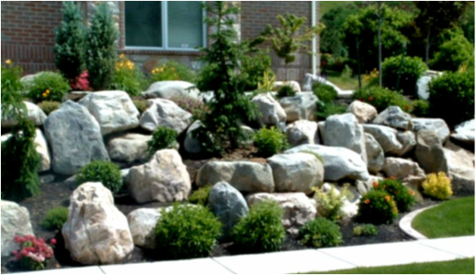

​

3-Planting thorny rose bushes and barberry bushes under the windows on the first floor will help keep intruders out. Planting these bushes in between the giant boulders around the perimeter of the home will add another layer of protection.  
  
4-Window alarms can be purchased at any hardware store for under $10. These alarms work similar to electronic security systems. When a window is opened past a certain point, the alarm will go off. You can put these small, inexpensive alarms on your doors as well.  
​  
​5-A dog is an excellent deterrent. A large breed tends to look scarier in general, any dog will offer some form of protection. You don't have to buy a pure bred German shepherd or similar protection dog. A mixed breed will be just as effective. If you cannot have a dog, you can fake out would-be attackers. Have some large chew toys and bones in the front yard area. Post a “Beware of Dog” sign on your fence or front door. Take it a step further and borrow large piles of dog scat to strategically place in your yard. You can even buy fake scat! Other paraphernalia like a leash, studded collar and heavy chain strewn about to really sell the guard dog idea is also helpful.  
​



6-Lighting is one of the best ways to deter bad guys. Bad guys like to lurk in the dark. They aren't big on lighted areas. Motion detector lights can be purchased for less than $20. Install them in areas that tend to be shrouded in darkness. Don't count on the street lights working. You can invest in solar-powered motion lights that will ensure you always have light, even in the darkness.  
  
7-Install dead bolts on your front and back doors. If you have a garage door, put one on there too. The dead bolt should be a Grade 1 or 2 at the minimum. Use long screws, 3 to 6 inches in length, to install strike plates. You want them secure and not easily wiggled and broken into. While it isn't exactly cheap, check with your local Habitat for Humanity store to see if you can get a great deal on a solid wood door. Solid doors are much more secure than the lower-quality doors that are hollow in the center.  
  
8-Window locks are cheap and easy to install. While a window lock may not be enough to keep a determined person out, it will stop the average thief. The locks will prevent the window opening more than a few inches, similar to what you would find in a hotel room with an outward facing window. A wooden dowel in the window track will be just as effective. This is a good idea for a sliding glass door. An old mop or broom handle will work great in the track of sliding glass doors.  
  
9-Rig up tripwires around the perimeter of your home to alert you to potential intruders. This can be as simple as fishing line and some old cans. String the wire low to the ground. If you have grass, the grass will hide it well or a flower bed or some shrubs. Attach some cans, a cow bell or even some washers to the end of the fishing line. When a potential intruder crosses the line, the alert will sound and you will have the chance to get ready for an attack.



10-Bars on the windows are not appealing for most, but they are an effective deterrent. If you are not comfortable with the bars as a part of your permanent look, you can have them sitting in the garage ready to put on in a hurry. You really only need bars on the ground level floors. They don't have to be pretty. Have the hardware in place and ready to use at the first sign of trouble. Check second hand stores and the Habitat stores for secondhand security bars.  
  
11-Make your home look undesirable. This can be achieved in a number of ways. Toss out clothing, garbage and break a chair. Toss it all in the front yard to make it look like your home has already been ransacked. Putting the plywood over the windows further lends to that look. Put some empty food cans and food containers around as well. You want potential thieves to look at your house and assume it has been stripped and isn't worth the effort.  
  
12-Keeping with the ramshackle look, have a can of spray paint on standby. When things get ugly, graffiti the outside of your house. If the home looks worthless, thieves on a mission to find things of value, food and water are not going to bother when the house next door looks perfect.



13-Caution tape and quarantine signs can also go a long way to keep bad guys away. You can buy these things online or at a party store. You can take it a step further by keeping extra ketchup and/or red spray-paint on hand to create “blood spatters” on the walkway, doors and windows. Most people are not going to want to mess with a nasty crime scene. If you are in a pandemic situation, the quarantine sign will be enough to deter any healthy looters away.  
  
14-Say it like it is. Put up signs announcing you will shoot anybody who crosses onto your property. The very threat of a gun is enough to keep most people at way. You can make your own signs or buy some very creative signs on the internet. The message is the same, trespassers will be shot or injured. It tells potential trespassers you are armed and willing to fight.  
  
15-Fences that include barbed wire along the top are certainly effective, but they are not always convenient. If you live in the suburbs, barbed wire could be an issue. If you are going to use a tall fence as part of your protection plan, make sure it encompasses the entire property. A working gate that can be locked or blocked is a must. A short fence that can be easily jumped isn't going to do much. Make the fence effective by making sure it is at least 6 feet high and made of a material that isn't easily smashed or crashed.  
 ​​​​

Protecting your home requires brains and brawn. You want to outsmart the bad guys without wasting a lot of money on weapons and other expense equipment that can be easily taken or destroyed. Take a walk around your home and identify any areas that are susceptible for break-ins. Take action now so you are ready for anything. If you can avoid violence, it is always going to be better for you. Take the time to get the supplies mentioned above so you are ready at a moment's notice. You don't need the additional stress.  
​

​[**Here is a Method That is Helping Thousands to “Bullet Proof” Their Homes**](http://757867fkrhkier0xy7w61mrl6u.hop.clickbank.net/?tid=POST)  
[**and Keep Their Families Safe in a SHTF Scenario Click Here**](http://757867fkrhkier0xy7w61mrl6u.hop.clickbank.net/?tid=POST)

**Fosmon motion sensor.** The best thing about the Fosmon motion sensor is that it can be used as a standalone unit, meaning you don’t have to purchase an Amazon Alexa or some sort of Smart Hub.

Basically, this sensor comes with a transmitter and sensor so when the sensor detects motion, it will cause the transmitter to emit a sound such as a chime alerting you to the motion.

This is a no-frills detector and doesn’t include any Smartphone alerts.

It’s very basic, with wireless install and features 52 ringtones for whenever motion is detected.

The motion sensor has a 110-degree field of vision and a detection range up to 16 feet.

**Kangaroo motion sensor.** When it comes to inexpensive motion sensors, the Kangaroo unit is one of the few that will alert you on your Smartphone, which can be a huge convenience.

With a basic design, the Kangaroo motion sensor is easy to install and controllable through the mobile app.

You’ll receive alerts whenever motion is detected and you can avoid false alarms with its pet friendly design features.

In addition, the Kangaroo sensor can detect movement up to 15 feet away.

You can choose to monitor your own home with a free basic plan or go with a complete plan, which includes the option to have professional monitoring.

**Geeni smart motion sensor.** This motion sensor connects to your Wi-Fi and doesn’t require a hub or another device to work.

Its instant alerts send a notification to your smartphone when movement is detected and you can also integrate the unit to work with Geeni lights that can turn on when motion is detected.

The motion sensor can be installed with an adhesive or with screws so it can be moved if used in an apartment or temporary location.

The Geeni sensor has a 110-degree field of vision and can detect motion up to 25 feet away.

These days, having a professional home security system with lights, sensors, alarms, and cameras can easily cost thousands of dollars.

Last week, a relative of mine in Las Vegas received a quote to install basic security cameras and it was going to cost $4,000.

If you have the money, certainly do it.

But, for a very inexpensive price, you can install motion detectors inside your home that you can monitor yourself.

**Fosmon motion sensor.** The best thing about the Fosmon motion sensor is that it can be used as a standalone unit, meaning you don’t have to purchase an Amazon Alexa or some sort of Smart Hub.

Basically, this sensor comes with a transmitter and sensor so when the sensor detects motion, it will cause the transmitter to emit a sound such as a chime alerting you to the motion.

This is a no-frills detector and doesn’t include any Smartphone alerts.

It’s very basic, with wireless install and features 52 ringtones for whenever motion is detected.

The motion sensor has a 110-degree field of vision and a detection range up to 16 feet.

**Kangaroo motion sensor.** When it comes to inexpensive motion sensors, the Kangaroo unit is one of the few that will alert you on your Smartphone, which can be a huge convenience.

With a basic design, the Kangaroo motion sensor is easy to install and controllable through the mobile app.

You’ll receive alerts whenever motion is detected and you can avoid false alarms with its pet friendly design features.

In addition, the Kangaroo sensor can detect movement up to 15 feet away.

You can choose to monitor your own home with a free basic plan or go with a complete plan, which includes the option to have professional monitoring.

**Geeni smart motion sensor.** This motion sensor connects to your Wi-Fi and doesn’t require a hub or another device to work.

Its instant alerts send a notification to your smartphone when movement is detected and you can also integrate the unit to work with Geeni lights that can turn on when motion is detected.

The motion sensor can be installed with an adhesive or with screws so it can be moved if used in an apartment or temporary location.

The Geeni sensor has a 110-degree field of vision and can detect motion up to 25 feet away.

These days, having a professional home security system with lights, sensors, alarms, and cameras can easily cost thousands of dollars.

Last week, a relative of mine in Las Vegas received a quote to install basic security cameras and it was going to cost $4,000.

If you have the money, certainly do it.

But, for a very inexpensive price, you can install motion detectors inside your home that you can monitor yourself.

Weapon speed deployment matters

No matter how perfect a holster is, there is always a delay in getting your weapon ready...

For me it doesn't matter if I'm at the office, in my truck or in a deep sleep...I can deploy my gun in seconds if I need to.

How?

Well we have finally found a simple solution involving magnets.

Night stand gun on safety

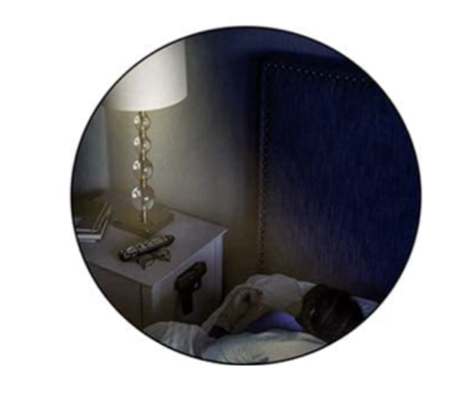 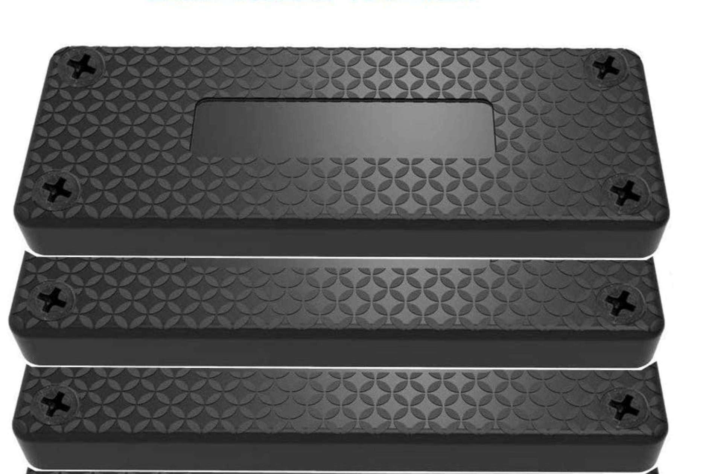

Under the desk

